Used orbital data for Galassia for a pass on 2018/10/19 04:52:24 as a representative sample.

Assuming observations are made from our MD1 ground station.

Highest Elevation angle reached about 48 degree above horizon.

Elevation is above 20 degree for around 5 minutes.

Doppler shift of 1GHz clock rate observed from ground station

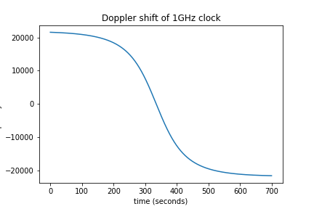

Doppler shift of 4.5 MHz event rate observed from ground station

